Q1. What is the difference between 'Paste' and 'Paste Special' in Excel? Briefly explain with examples.
Sol.
1. Paste - It inserts everything exactly as copied.
What it pastes:
- Values
- Formulas
- Formatting (font, color, borders)
- Comments, data validation, etc.
Example:
- Cell A1 contains =B1+C1 with yellow fill.
- Copy A1 → Paste in A2
➡ A2 will also contain the formula =B2+C2 and the same yellow formatting.

2. Paste Special - Paste Special lets you choose specific components of the copied data.
Common options with examples:
- Values
Paste only the result, not the formula.
  - =B1+C1 → Paste Special → Values
➡ Only the number (e.g., 50) is pasted.
- Formulas
Paste only the formula, without formatting.
- Formats
Paste only formatting (colors, fonts, borders).
- Transpose
Convert rows into columns or columns into rows.
- Multiply / Add / Subtract / Divide
Perform calculations while pasting.
Example:
- Copy cells with formulas → Paste Special → Values
➡ Useful when sharing data or locking results.

Q2. Describe the functions and usefulness of 'Freeze Panes' and 'Split Panes' in Excel.
Sol.
Freeze Panes -
Function: Freeze Panes locks selected rows and/or columns so they remain visible while you scroll through the worksheet.
Usefulness:
- Keeps headers or key identifiers visible in large datasets
- Improves readability and data analysis
- Prevents losing context when scrolling
Example:
- Freezing the top row keeps column headings visible while scrolling down.
- Freezing the first column keeps row labels visible while scrolling right.

Split Panes -
Function: Split Panes divides the worksheet window into two or four separate panes, each with its own scroll bar.
Usefulness:
- Allows viewing and working on different parts of the same worksheet simultaneously
- Useful for comparing data from distant rows or columns
- Helps analyse large worksheets without switching views
Example:
- Splitting vertically lets you view column A and column Z at the same time.
- Splitting horizontally lets you compare top and bottom sections of a sheet.

Q3. Explain the difference between inserting a new row and inserting a new column in Excel. Can you insert multiple rows or columns at once?
Sol.
Inserting a New Row
- Adds a horizontal row to the worksheet.
- The new row is inserted above the selected row.
- Existing rows below shift downward.
- Used when you want to add more records or entries.
Example:
If you select row 5 and insert a row, the new row becomes row 5 and the original row 5 moves to row 6.

Inserting a New Column
- Adds a vertical column to the worksheet.
- The new column is inserted to the left of the selected column.
- Existing columns to the right shift rightward.
- Used when you want to add a new field or attribute.

Example:
If you select column C and insert a column, the new column becomes column C and the original column C shifts to column D.

Inserting Multiple Rows or Columns at Once -
Yes, you can insert multiple rows or columns at the same time.
How:
- Select multiple rows (or columns) equal to the number you want to insert.
- Right-click → Insert, or use Home → Insert → Insert Sheet Rows/Columns.
Example:
- Selecting 3 rows and inserting will add 3 new rows at once.
- Selecting columns B to D and inserting will add 3 new columns together.

Q4. What are logical functions in Excel? Provide examples of at least two logical functions and their applications.
Sol.
Logical Functions in Excel
Logical functions in Excel are used to test conditions and return results based on whether the condition is TRUE or FALSE. They help in decision-making and automate calculations based on criteria.

i) IF Function
Purpose:
Checks a condition and returns one value if the condition is TRUE, and another value if it is FALSE.
Syntax:
=IF(logical_test, value_if_true, value_if_false)
Example & Application:
- Formula:
=IF(A1>=40, "Pass", "Fail")
- Application:
Used in result sheets to determine whether a student has passed or failed based on marks.

ii) AND Function
Purpose:
Returns TRUE if all conditions are TRUE; otherwise returns FALSE.
Syntax:
=AND(condition1, condition2, ...)
Example & Application:
- Formula:
=AND(A1>=40, B1>=40)
- Application:
Checks whether a student has passed in all subjects.

iii) OR Function (Additional Example)
Purpose:
Returns TRUE if any one of the conditions is TRUE.
Example:
=OR(A1="Yes", B1="Yes")
Application:
Used to check eligibility if at least one criterion is satisfied.

Q5. Discuss the purpose of 'XLOOKUP' and how it differs from the traditional 'VLOOKUP' function.
Sol.
Purpose of XLOOKUP
XLOOKUP is a modern lookup function in Excel used to search for a value in a range or array and return a corresponding value from another range. It is designed to replace older lookup functions like VLOOKUP, HLOOKUP, and even many uses of INDEX–MATCH.
Basic syntax:
=XLOOKUP(lookup_value, lookup_array, return_array, [if_not_found], [match_mode], [search_mode])
How XLOOKUP Differs from VLOOKUP -
Aspect | XLOOKUP | VLOOKUP
Lookup direction | Can look left or right | Can look only to the right
Column index required | No column number needed | Requires column index number
Exact match | Default behavior | Must specify FALSE
Handling not found values | Built-in if_not_found argument | Requires IFERROR
Search direction | Can search top-to-bottom or bottom-to-top | Top-to-bottom only
Range changes | Safer (no break if columns inserted) | Can break if columns are added/deleted
Ease of use | More flexible and readable | More rigid

Example Comparison
Using VLOOKUP:
=VLOOKUP(A2, A2:D10, 3, FALSE)
- Looks for value in column A
- Returns data from the 3rd column
- Breaks if column positions change

Using XLOOKUP:
=XLOOKUP(A2, A2:A10, C2:C10, "Not Found")
- Clearly defines lookup and return ranges
- Works even if columns move
- Returns a custom message if not found

Key Advantages of XLOOKUP
- More flexible and robust
- Easier to read and maintain
- Eliminates common VLOOKUP limitations
- Works as a powerful replacement for multiple lookup functions

Q6. Create a worksheet titled 'Employee Data' with columns: Name, Age, Department. Add 5 rows of data.
Format as follows:
- Bold and center-align the header row
- Apply a fill color
- Auto-fit column width
(Include a screenshot showing your formatted table.)
Sol. Please find below screenshot -
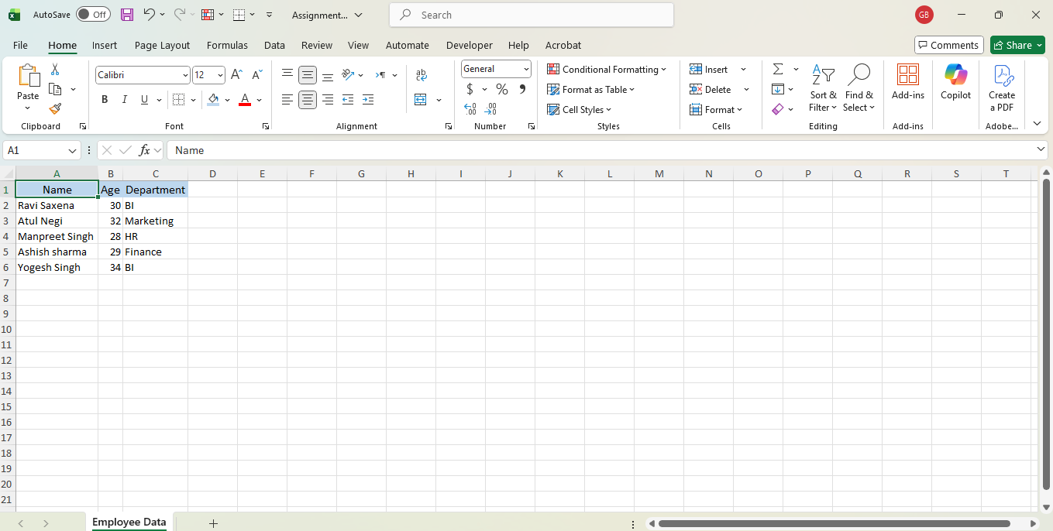
Q7. Demonstrate how to insert and delete multiple rows and columns in Excel.
(Provide screenshots before and after the changes.)
Sol. Please find below screenshot for inserting multiple rows and columns -
Rows -
Screenshot before inserting multiple rows -
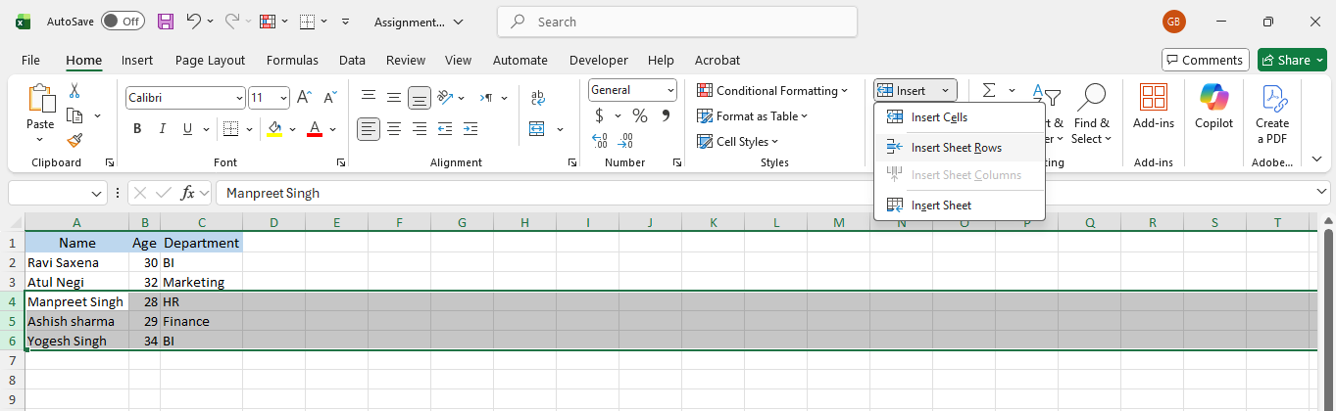

Screenshot after inserting multiple rows -
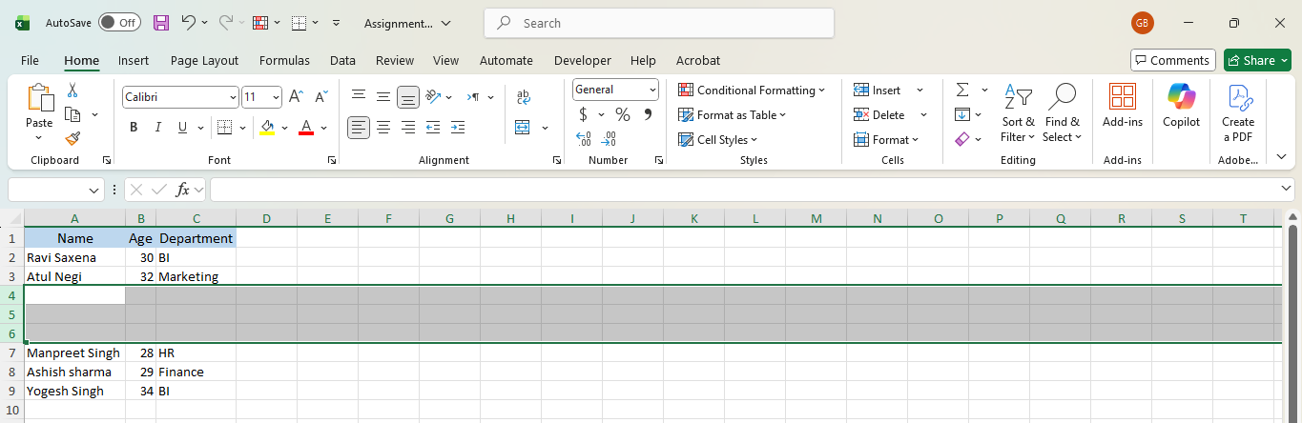

Columns -
Screenshot before inserting multiple columns -
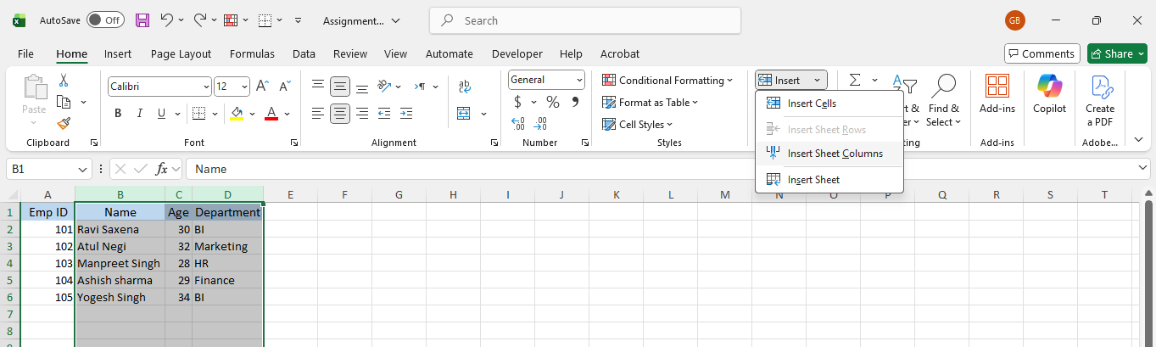

Screenshot after inserting multiple columns -
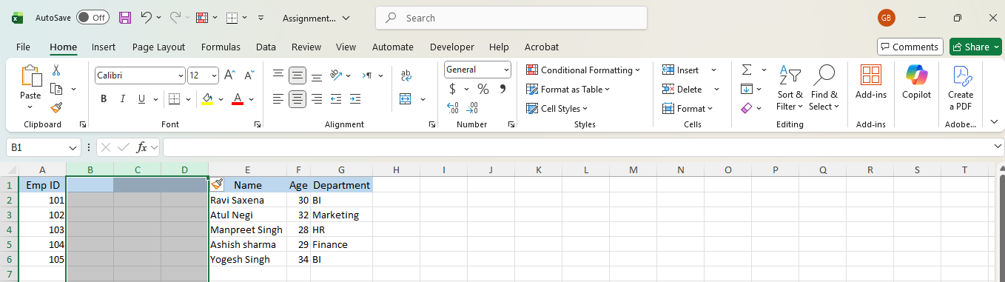

Q8.Use Excel's 'Find and Replace' feature to update department names in a sample table.
(Include a screenshot showing the replaced data.)
Sol. Screenshot before replacing department -
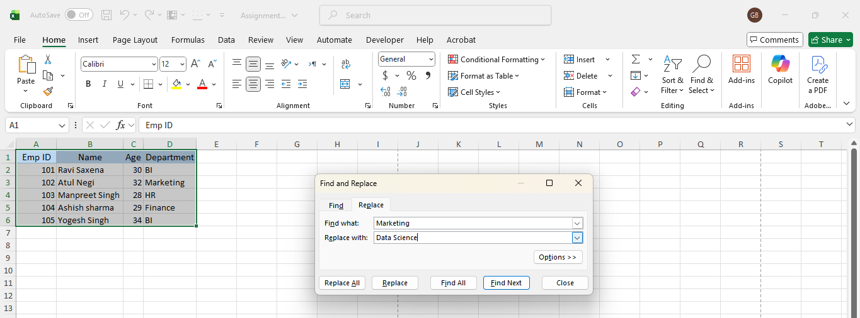
Screenshot after replacing department -
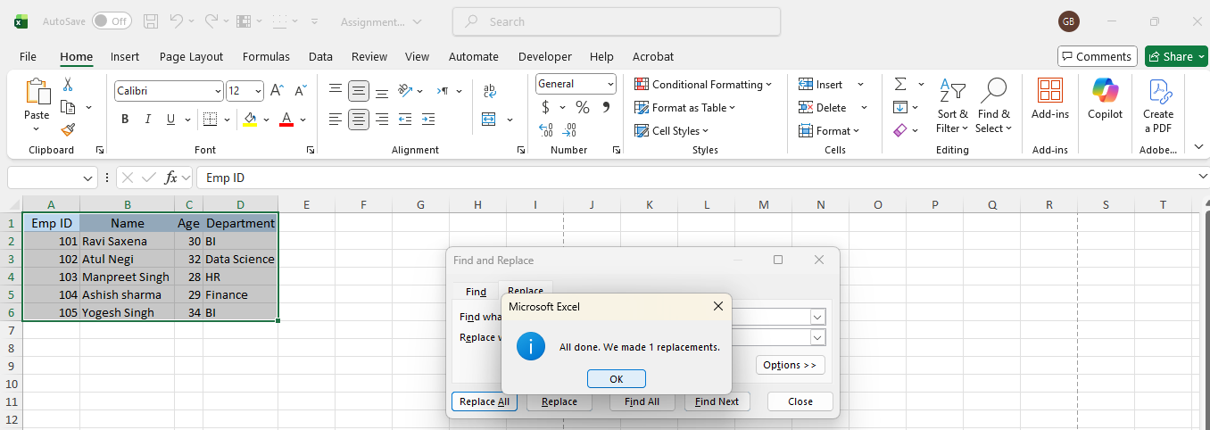

Q9. Create a small numerical dataset and apply the following functions:
- AVERAGE
- MAX
- MIN
(Include a screenshot showing the formulas and their results.)
Sol. Screenshot of result -
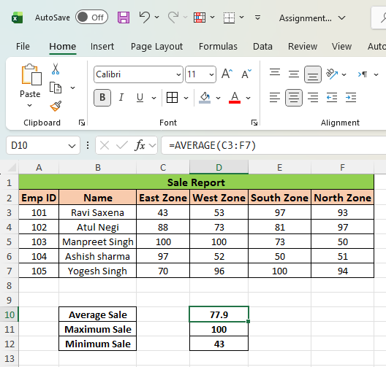
Screenshot of formulas -
    - Average -

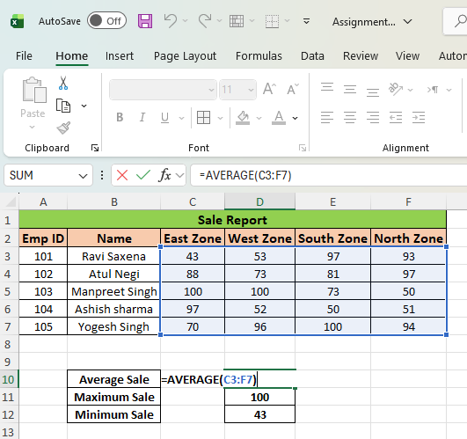

    - Maximum -

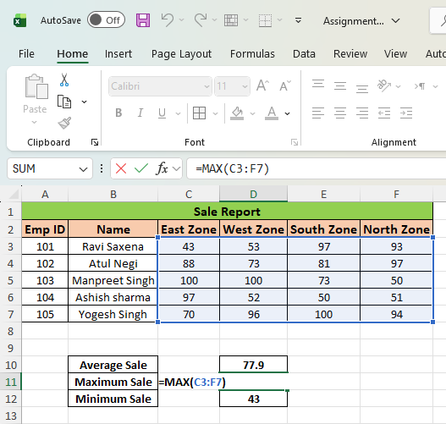

    - Minimum -

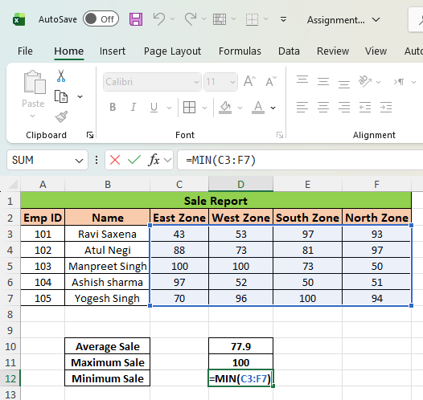

Q10. You're working with a dataset that contains missing values. As a Data Scientist, explain how you'd detect and handle missing data using Excel. Mention tools like:
- Go To Special
- ISBLANK
- COUNTBLANK
(Include a screenshot showing how blanks are identified or processed.)

Sol. In Excel, I would detect and manage missing values using the following tools and functions:
- Detecting Missing Data in Excel
- Go To Special (Blanks) - Purpose: Quickly locate all blank cells in a dataset.
Steps:
- Select the entire dataset
- Press Ctrl + G → Click Special
- Choose Blanks → Click OK

Use case:
All blank cells get selected at once, making it easy to:
- Highlight missing values
- Delete rows/columns
- Enter a default value (e.g., 0 or “Not Available”)

Screenshot -

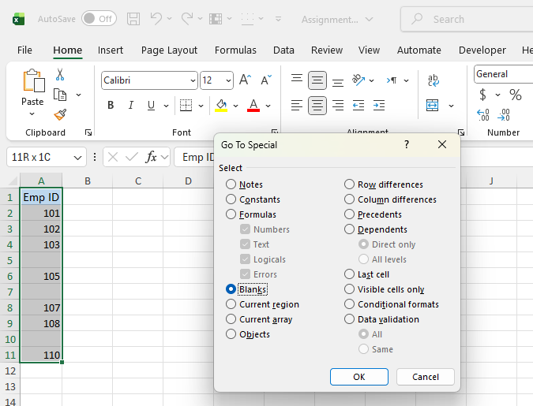

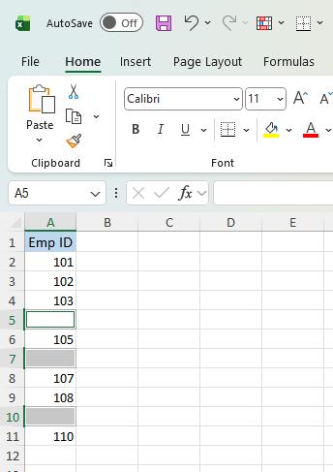

- ISBLANK Function
Purpose: Check whether a specific cell is empty.
Syntax: =ISBLANK(A2)

Output:
- TRUE → Cell is blank
- FALSE → Cell contains data
Screenshot -
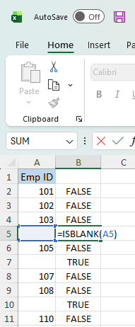

- COUNTBLANK Function
Purpose: Count how many blank cells exist in a range.
Syntax : =COUNTBLANK(B2:B10)
Use case:
Helps quantify missing data before deciding whether to:
- Remove rows
- Replace values
- Ignore the column entirely

Screenshot -
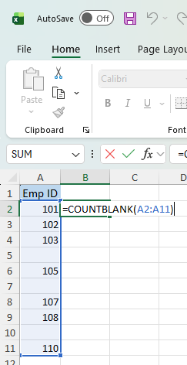

- Handling Missing Data
Once detected, I may:
- Remove rows/columns if missing data is minimal
- Impute values (mean/median for numerical data, mode for categorical data)
- Flag missing data using helper columns for further analysis

